Q1: Candlestick Pattern Analysis — Infosys (INFY)
Date | Open | High | Low | Close
21-May | 1196.10 | 1201.80 | 1177.00 | 1181.20
22-May | 1182.50 | 1191.80 | 1172.50 | 1174.50
25-May | 1183.00 | 1185.00 | 1166.10 | 1168.50
26-May | 1166.30 | 1180.70 | 1162.90 | 1167.70
27-May | 1161.00 | 1167.30 | 1155.00 | 1159.90
29-May | 1182.00 | 1210.00 | 1153.60 | 1160.90
01-Jun | 1175.00 | 1217.00 | 1173.70 | 1202.50
02-Jun | 1232.50 | 1278.90 | 1232.50 | 1270.80
03-Jun | 1242.10 | 1249.90 | 1216.00 | 1222.60
04-Jun | 1208.00 | 1215.20 | 1196.20 | 1201.30
05-Jun | 1220.00 | 1223.80 | 1194.30 | 1197.50
08-Jun | 1177.50 | 1200.70 | 1176.50 | 1187.60
09-Jun | 1193.60 | 1193.60 | 1167.30 | 1180.30
10-Jun | 1160.10 | 1171.40 | 1143.30 | 1145.30
11-Jun | 1129.70 | 1133.70 | 1109.00 | 1114.60
12-Jun | 1120.00 | 1123.30 | 1111.50 | 1116.40
15-Jun | 1130.00 | 1151.00 | 1123.00 | 1134.90
16-Jun | 1136.90 | 1153.80 | 1123.20 | 1143.60
17-Jun | 1149.00 | 1162.50 | 1148.00 | 1157.70
18-Jun | 1142.90 | 1142.90 | 1125.30 | 1127.50
19-Jun | 1062.30 | 1066.00 | 1030.00 | 1051.40
Walking through the story this chart tells:
Late May — repeated tests of support. From 22nd to 27th May, the stock keeps making slightly lower closes (1174 → 1168 → 1167 → 1159) but the lows on 27th and 29th May both land around 1153–1155. That's a price action zone — the stock kept getting bought up around the same level, refusing to break lower.
1st–2nd June — near Bullish Marubozu. On 2nd June, Open (1232.50) exactly equals the Low, and the Close (1270.80) is right near the High (1278.90). Almost no lower shadow at all — classic Marubozu territory. This came right after a strong gap-up day on 1st June too. Together this reads as a sharp, aggressive round of buying right after the stock held its support zone — exactly the kind of "sentiment flip" the marubozu is supposed to signal.
3rd–11th June — steady bearish slide. From the 2nd June high of 1278.90, the stock declines almost every single day for over a week, closing lower each time, eventually dropping over 12% to 1114.60 by 11th June. No major reversal candle here — just a grinding downtrend.
12th June — Spinning Top / Doji. Open 1120.00, Close 1116.40 — barely any real body, with small shadows on both sides. This is the textbook "indecision" candle that shows up after a sharp downtrend, where neither bulls nor bears can push further. And sure enough — the very next three sessions (15th, 16th, 17th June) all close higher, confirming the short pause did mark a temporary bottom.
18th June — near Bearish Marubozu. Open (1142.90) exactly equals the High, no upper shadow at all, closing near the low of the day. This is heavy, immediate selling pressure right from the open — a clear warning sign that the brief 3-day bounce was running out of steam.
19th June — Gap-down crash with a Hammer-like recovery. This is the big one. The stock gapped down massively — opening at 1062.30 versus the previous close of 1127.50 (a 5.7% gap down on the open alone) — and made a fresh 52-week low at 1030. But notice it didn't close at the low; it recovered to 1051.40 by end of day, meaning some buying did show up near 1030. So while this is overwhelmingly a bearish day (a textbook example of "gap down opening showing bear enthusiasm"), the small recovery off the lows hints that 1030 might act as a short-term floor — worth watching if the stock retests that level again.
Quick interpretation: the stock built support around 1153–1160 in late May, broke out aggressively, then gave it all back and more during a sector-wide IT sell-off into 19th June, with the spinning top on 12th June being the only real pause along the way.
Q2: SMA & EMA (5-day) and Predicting the Next Value
Using the same closing prices, here's the 5-day Simple Moving Average and 5-day Exponential Moving Average, calculated the same way the Marico example in the reading material did it:
Date | Close | SMA(5) | EMA(5)
27-May | 1159.90 | 1170.36 | 1170.36
29-May | 1160.90 | 1166.30 | 1167.21
01-Jun | 1202.50 | 1171.90 | 1178.97
02-Jun | 1270.80 | 1192.36 | 1209.58
03-Jun | 1222.60 | 1203.34 | 1213.92
04-Jun | 1201.30 | 1211.62 | 1209.71
05-Jun | 1197.50 | 1218.94 | 1205.64
08-Jun | 1187.60 | 1215.96 | 1199.63
09-Jun | 1180.30 | 1197.86 | 1193.19
10-Jun | 1145.30 | 1182.40 | 1177.22
11-Jun | 1114.60 | 1165.06 | 1156.35
12-Jun | 1116.40 | 1148.84 | 1143.03
15-Jun | 1134.90 | 1138.30 | 1140.32
16-Jun | 1143.60 | 1130.96 | 1141.41
17-Jun | 1157.70 | 1133.44 | 1146.84
18-Jun | 1127.50 | 1136.02 | 1140.40
19-Jun | 1051.40 | 1123.02 | 1110.73
(First 4 days have no value since you need at least 5 closes before the first average can be calculated.)
You can see the EMA reacting faster than the SMA — for instance after the crash on 19th June, the EMA dropped to 1110.73 while the SMA only fell to 1123.02, because EMA weighs the latest price more heavily.
Predicting the next value: Since we don't have tomorrow's actual closing price yet, the simplest beginner-friendly approach is to use the latest EMA value itself as our forecast for the next close — because EMA is already a smoothed, recency-weighted estimate of "where the price wants to be." Using that:
- Predicted next close ≈ 1110.73
- Predicted next 5-day SMA ≈ 1118.19 (drop 18-Jun's 1127.50 from the window, add the predicted 1110.73)
- Predicted next 5-day EMA ≈ 1110.73 (since the input and previous EMA converge here)
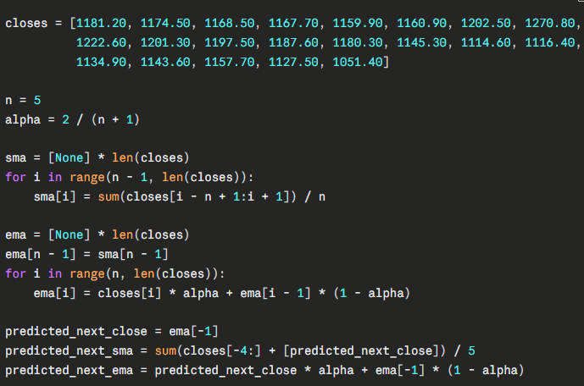

Since the trading system rule from the reading is "buy when price > EMA, exit when price < EMA" — right now Infosys's last close (1051.40) is well below its 5-day EMA (1110.73), so by that rule you'd still be in a "stay out / short" zone, not a buy signal yet.

Q3: Indicator Analysis — RSI, MACD & Bollinger Bands on Infosys (INFY)
To make MACD and Bollinger Bands actually mean something (they both need a longer lookback to settle down — especially MACD's 26-day EMA), I pulled close to 3 months of real daily closes (6th March to 19th June 2026) instead of just the 21 days from before. Here's how the indicators evolved over the most relevant stretch:
Date | Close | RSI(14) | MACD | Signal | Histogram | BB Mid | BB Upper | BB Lower
12-May | 1140.30 | 33.10 | -30.65 | -24.55 | -6.10 | 1217.71 | 1348.82 | 1086.60
14-May | 1095.00 | 27.64 | -36.96 | -28.41 | -8.55 | 1199.51 | 1335.29 | 1063.73
19-May | 1196.90 | 50.21 | -29.66 | -31.02 | 1.36 | 1174.90 | 1273.38 | 1076.43
01-Jun | 1202.50 | 53.51 | -11.45 | -18.69 | 7.24 | 1162.91 | 1215.83 | 1110.00
02-Jun | 1270.80 | 64.39 | -2.70 | -15.50 | 12.79 | 1168.04 | 1238.87 | 1097.20
03-Jun | 1222.60 | 54.66 | 0.34 | -12.33 | 12.67 | 1170.26 | 1244.91 | 1095.61
08-Jun | 1187.60 | 48.61 | 0.60 | -5.86 | 6.47 | 1174.12 | 1250.84 | 1097.41
09-Jun | 1180.30 | 47.32 | -0.48 | -4.79 | 4.30 | 1174.29 | 1251.04 | 1097.54
11-Jun | 1114.60 | 37.34 | -9.37 | -5.60 | -3.77 | 1174.12 | 1251.68 | 1096.55
12-Jun | 1116.40 | 37.74 | -13.24 | -7.13 | -6.11 | 1175.18 | 1248.85 | 1101.52
17-Jun | 1157.70 | 46.79 | -13.76 | -10.65 | -3.11 | 1174.08 | 1245.26 | 1102.89
18-Jun | 1127.50 | 41.63 | -15.15 | -11.55 | -3.59 | 1170.76 | 1244.11 | 1097.42
19-Jun | 1051.40 | 32.04 | -22.13 | -13.67 | -8.46 | 1164.28 | 1253.94 | 1074.61
RSI(14) — the oversold-overbought meter
RSI dipped to 27.64 on 14th May — properly oversold. And just like the textbook says, once it started "moving away from the oversold value," buying interest kicked in: the stock rallied from 1095 back up past 1196 within a week, and RSI climbed all the way to 64.39 by 2nd June (close to overbought, but not quite there).
Then the slide began. RSI has been steadily losing strength since — 48 → 41 → 37 → all the way down to 32.04 on 19th June. It's knocking on oversold's door again but hasn't broken below 30 yet. If you think of RSI like a fast bowler's pace through a long spell — it cools down gradually, it doesn't crash instantly — that's exactly what's happening here. One more bad session and we'd likely see it cross under 30.
MACD — the lagging confirmation tool
This is where it gets interesting. Track the centerline crossovers:
- 3rd June: MACD flipped from -2.70 to +0.34 — crossed above zero. Per the textbook, that's a bullish signal. Except notice — the stock had already rallied hard on 1st-2nd June before MACD caught up. That's MACD being a lagging indicator exactly as described — it confirmed the move after it happened, not before.
- 9th June: MACD flipped from +0.60 to -0.48 — crossed back below zero. Bearish signal. This time, it actually gave you a heads-up before the worst of the damage (10th-19th June, where the stock fell from 1180 to 1051).
So in this case, the lagging bearish crossover on 9th June would have gotten you out (or short) a full week before the 19th June crash — a genuinely useful signal here, even with the lag.
By 19th June, MACD (-22.13) is well below its signal line (-13.67), and the histogram (-8.46) is deeply negative — strong, accelerating bearish momentum, no sign of bottoming yet.
Bollinger Bands — the volatility ruler
Two things stand out:
- The bands were extremely wide in mid-May (Upper ~1335, Lower ~1063) — that's the 24th April crash day (a 6.93% single-day drop) still sitting inside the 20-day window, inflating the standard deviation. As that day rolled out of the window by early June, the bands tightened up nicely (Upper ~1215, Lower ~1110 by 1st June) — classic "volatility contraction."
- On 19th June, the close (1051.40) fell below the lower band (1074.61) entirely. That's not a normal "touch the band and bounce" setup — that's the stock getting violently shoved outside its usual volatility range in a single session (the gap-down crash we covered in Q1). The textbook logic says "buy near the lower band, expecting reversion to the average (1164.28 here)." But be careful with that here — this drop was driven by sector-wide news (the whole IT pack got hit), not just normal price noise. Treating a band-breach during a news shock the same way you'd treat a quiet pullback is exactly the kind of mistake the Grand Checklist tries to prevent — you'd want volume, S&R, and a candlestick confirmation (which we don't have yet from 19th June's red candle) before acting on this alone.
Putting it together: RSI says "getting close to oversold but not there," MACD says "bearish momentum is accelerating, no reversal signal yet," and Bollinger Bands say "this move is statistically extreme." None of the three are screaming "buy" in unison yet — which is exactly the kind of multi-indicator check the checklist in Q4 will format properly.
Code for the calculations
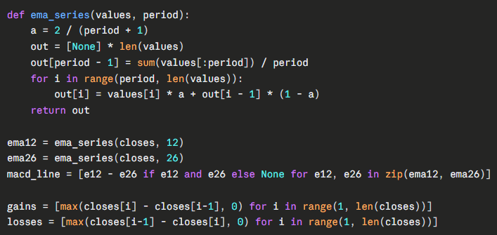
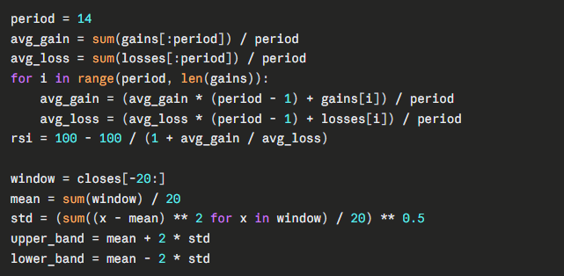
Q4: The Grand Checklist — Applied to Infosys
1. The stock should form a recognisable candlestick pattern.
This is just saying: don't trade on a random day, wait for the chart to "say something" through a pattern you recognise.
→ For INFY: Plenty of recognisable patterns showed up — the near-Marubozu rally on 2nd June, the Spinning Top on 12th June, the near-Bearish-Marubozu on 18th June, and the big gap-down crash candle on 19th June. The chart wasn't silent — it kept giving signals.
2. Support & Resistance should confirm the trade — your stoploss should sit around S&R.
The idea is your risk should be anchored to a real price level, not a random number.
→ For INFY: Late May built a support zone around 1153–1160 (tested twice). That zone is exactly where you'd have placed a stoploss for any long trade taken on the 1st-2nd June rally. Problem is — that support eventually broke completely on 19th June, all the way down to a fresh 52-week low of 1030. So the support didn't hold long-term; it only worked as a short-term floor.
3. Volumes should confirm — above-average volume on both the buy day and the sell day; low volume is a red flag.
Big institutional money moves volumes a lot; if volume is thin, the move could just be small retail noise.
→ For INFY: The average daily volume across our sample works out to roughly 16 million shares. Compare that to:
- 29th May (the support test day): 69.09M — over 4x average. Heavy volume right at support, consistent with real buying interest defending that level.
- 2nd June (the bullish breakout day): 36.03M — over 2x average. Strong conviction behind that rally.
- 19th June (the crash day): 45.67M — nearly 3x average. This wasn't a thin, easily-reversible move — real selling pressure backed it.
- 18th June (the bearish Marubozu-like day): 16.78M — right around average, nothing special. So that particular red candle, while pattern-wise bearish, didn't have outsized volume behind it.
So volume genuinely confirms the two big moves (2nd June rally, 19th June crash) but not the smaller bearish day on 18th June.
4. Check it against Dow Theory — primary/secondary trend, double/triple formations, recognisable Dow patterns.
This zooms you out from individual candles to the bigger picture.
→ For INFY: The primary trend is clearly bearish — the stock is down ~35% over the past year, from a 52-week high of 1728 to a 52-week low of 1030. The May-June bounce (1095 → 1270, roughly +16%) was just a secondary (counter-trend) rally inside that bigger downtrend — exactly the kind of "rally in a bear market" the theory describes. The support test in late May looked like it might form a double bottom, but it failed — price eventually broke clean through it to new lows, so there's no valid reversal formation here, just a continuation of the primary downtrend. One thing that does confirm Dow Theory's "all indices must confirm" rule: this wasn't INFY acting alone — the whole Nifty IT index crashed alongside it on 19th June, so the move had broad confirmation rather than being a stock-specific glitch.
5. Indicators should confirm — if they do, size up your trade; if not, stick to your original plan.
→ For INFY: From Q3, RSI is sliding toward oversold (32.04) but hasn't crossed under 30 yet, MACD is firmly bearish and still falling, and price has actually closed below the lower Bollinger Band. Two out of three (MACD, BB) are screaming "this move has gone too far," but none of them are giving a clean reversal signal yet (RSI especially needs to actually dip under 30 and then climb back above it before it counts as a real buy trigger, per the reading). So: indicators are confirming the bearishness, not confirming a bounce — yet.
6. RRR should be satisfactory — as high as possible if you're a beginner, at least 1.5 if you're active.
This is just basic risk management: never take a trade where you're risking more than you stand to gain.
Let's actually test two real trade ideas using INFY's numbers:
- Short trade on 18th June's bearish candle: Entry 1127.50, stoploss at the pattern high (1142.90) → risk = 15.40. If you'd held to the close on 19th June (1051.40), reward = 76.10. RRR = 4.94 — an excellent ratio. This is the kind of setup the checklist is designed to help you find.
- Contrarian long near 19th June's low: Entry around 1051.40, stoploss below the new low (say 1020) → risk = 31.40. Target back at the old support-turned-resistance zone (~1095) → reward = 43.60. RRR = 1.39 — below the 1.5 threshold for an active trader, and indicators (point 5) aren't confirming a bottom yet either. Per the checklist, a beginner should probably skip this one or size it very small — it doesn't clear the bar.
Overall verdict on INFY's recent performance: every signal — candlestick patterns, the failed support, volume on the down days, the primary downtrend under Dow Theory, and the indicators — is pointing the same direction: this has been a confirmed, broad-based downtrend, not a stock-specific blip. The checklist doesn't currently support a "buy the dip" trade with conviction; it supports staying cautious or looking for short setups until RSI actually breaks oversold and reverses, or volume dries up on a quiet, low-range day signaling sellers are exhausted.

